REST API
Udemy Courses:
AWS Serverless REST APIs for Java Developers
REST Assured API Automation from scratch + Framework + CI

Representational State Transfer (REST) Protocol, useful for designing a web services via architectural approach.

Special points:
- REST Apis are mostly implemented using http protocol
- Service side implementation can be different languages such as JAVA, Python, .NET
- The support data exchange could be in different format, such as JSON or XML
- To communicate with the REST Api, the client application uses http, GET, POST, PUT, PATCH, DELETE requests.
- REST API is stateless. It means the

Types of HTTP methods and features

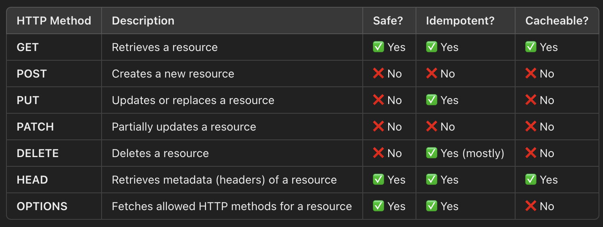

Status Code
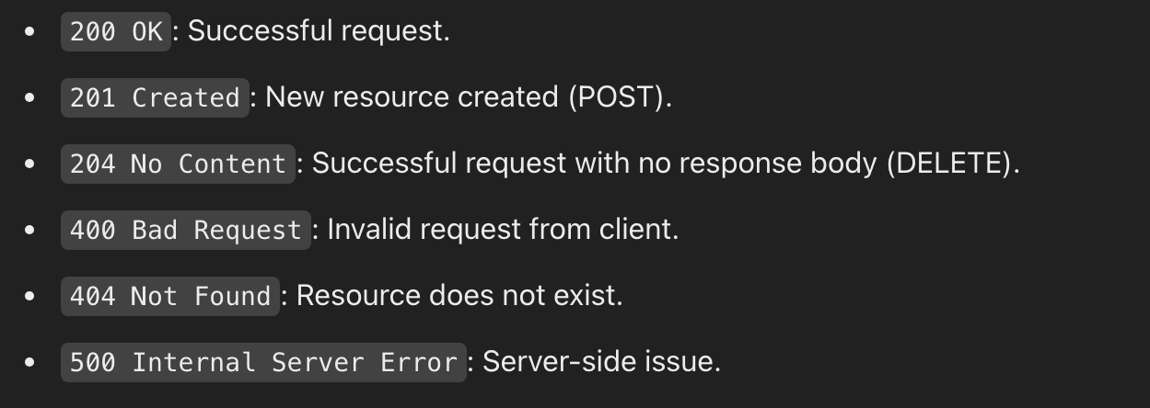

Size Limitation for HTTP
Only GET and DELETE method has size limitation of 2048 in IE, but chrome and other browsers allow more than that. Also, no message body allowed in the request.

Standards of REST Style
- It is important to follow the REST style which enables to guess the end point of the REST API.
- The resource should be a noun and not a verb. Additionally, it should be plural

i.e. create users REST URL should be

POST https://my-server.com/users

create server resource

- Users should be the Resource

Get Method should be like as follows

GET https://my-server.com/users/id-of-the -resource
- URL should not be too complex, or lengthy

System under Test

https://restful-booker.herokuapp.com/apidoc/index.html

Auth - CreateToken

End point: https://restful-booker.herokuapp.com/auth

Test Cases:
#1. Validate correct Status code (200) and response feilds for valid authentication.
#2. Validate Mandatory Parameters and correct Status Code (401) for Error messages.
#3. Validate null values for Mandatory Parameters, Status Code (400)
#4. Validate incorrect header types, Error code 501
#5. Length validation for input parameters, username and password

TestNG Test Framework for REST API

Programming Language:
JAVA 23
Build Tool:
Maven

Executing Commands:
cd /<path-to-source-code>/restful-booker.herokuapp.com
mvn clean test

Dependencies:
Following Maven plugins are being used.
rest assured: version 5.5.1
testNg
Lombok
Jackson Databind
Apache log4j

IDE Plugin:
IntelliJ TestNG plugin
# Latest Idea IDE has bundled testNG plugin

Liberties Used:

Hamcrest Package for Asserting responses.

Ref: https://hamcrest.org/JavaHamcrest/tutorial

Why Hamcrest?
Test Case readability is very high than the Junit Assertions
Descriptive Error logs, easy to debug and troubleshoot
Type safety and showing at the compilation time itself

Hamcrest matcher class and other assertions helps for assert different types of objects in code. It helps to validate Objects, Texts, Logics, Numbers, and Collections. Additionally, testers can customize these assertions as their requirements. Furthermore, to increase the readability, it has “is” method which does not add extra behaviour but increase the code readability.

Setup
Import static methods, as most of the methods are conflicts with the testNg methods.

import static org.hamcrest.MatcherAssert.assertThat;
import static org.hamcrest.Matchers.contains;
import static org.hamcrest.Matchers.equalTo;

contains() -> checking for element’s value in the response body, should be many elements and in the same order, case sensitive

containsInAnyOrder() -> checking for element’s value in the response body, should be many elements and in any order, case sensitive

equelTo() – checking for elements value in the response body

empty() - > you can check value of the element is not empty as follows: - is(not(empty())

Validations:

Header Validations:
Header validations are done with assertThat() method of restAssured followed by below methods.
- header ()
- headers ()

Jackson Data Bind
Test framework uses Json Objects to be created for request payload, which can be done using Jackson Data Bind plugin.

Logging

Log4j from Apache.org.

Lombok Annotations
Intro:
Framework used Lombok annotations because of the following features.
- Reduce code
- Builder patterns support

Setup:
Ref: https://projectlombok.org/features/
Maven repository for download the dependency, and the plugin will be required if you use older version of IntelliJ.

Example:
Test framework implemented @Setter, Getter, Builder Annotations to implement setters, getters and builder classes in the POJO classes when defining Json objects.

Json Schema Validation
A validator for your Json document,
We can generate our Json Schema using following tool, but it is advisable to get it from the development team as it will be different to generic schemas.

Tool: https://jsonschema.net/app/schemas/0
The Schema should be stored in the class path.
In my example, I have stored in test/schemas folder.

It is important to validate response from your REST service when testing the API. Rest Assure uses dependent plugin to validated Json Schema.

https://mvnrepository.com/artifact/io.rest-assured/json-schema-validator

More reading about validation is : https://github.com/rest-assured/rest-assured/wiki/usage#json-schema-validation

Jackson Annotations

Not Null
Non Default
Non Empty
JSON ignore

POJO Classes

JAVA serialization and why

Java serialization helps in platform independency. Serialized java classes can be stored in or transfer into different platform and execute it in that platform after deserialized.
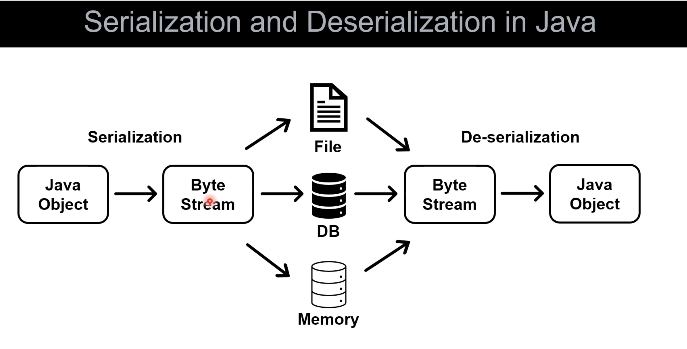

Liberties useful for serialize/deserialize for JAVA Objects to XML/JSON Objects

Ref: https://github.com/rest-assured/rest-assured/wiki/usage#object-mapping

- Jackson
- Gson
- TAXB

POJO class generation tool
https://www.jsonschema2pojo.org

Property Loader
A singleton class to load properties from the config.properties file and data.properties files.

GIT repository

Create github project

Commands
git init
git status # provide the git files
touch .gitignore # add folders and files needs to be ignored in your repo

git add –all # staging all the files to commit

git remote add origin https://github.com/rukmalhe/restfulTestNg.git
git commit -m “initial”
git remote -v
git push -u origin main

